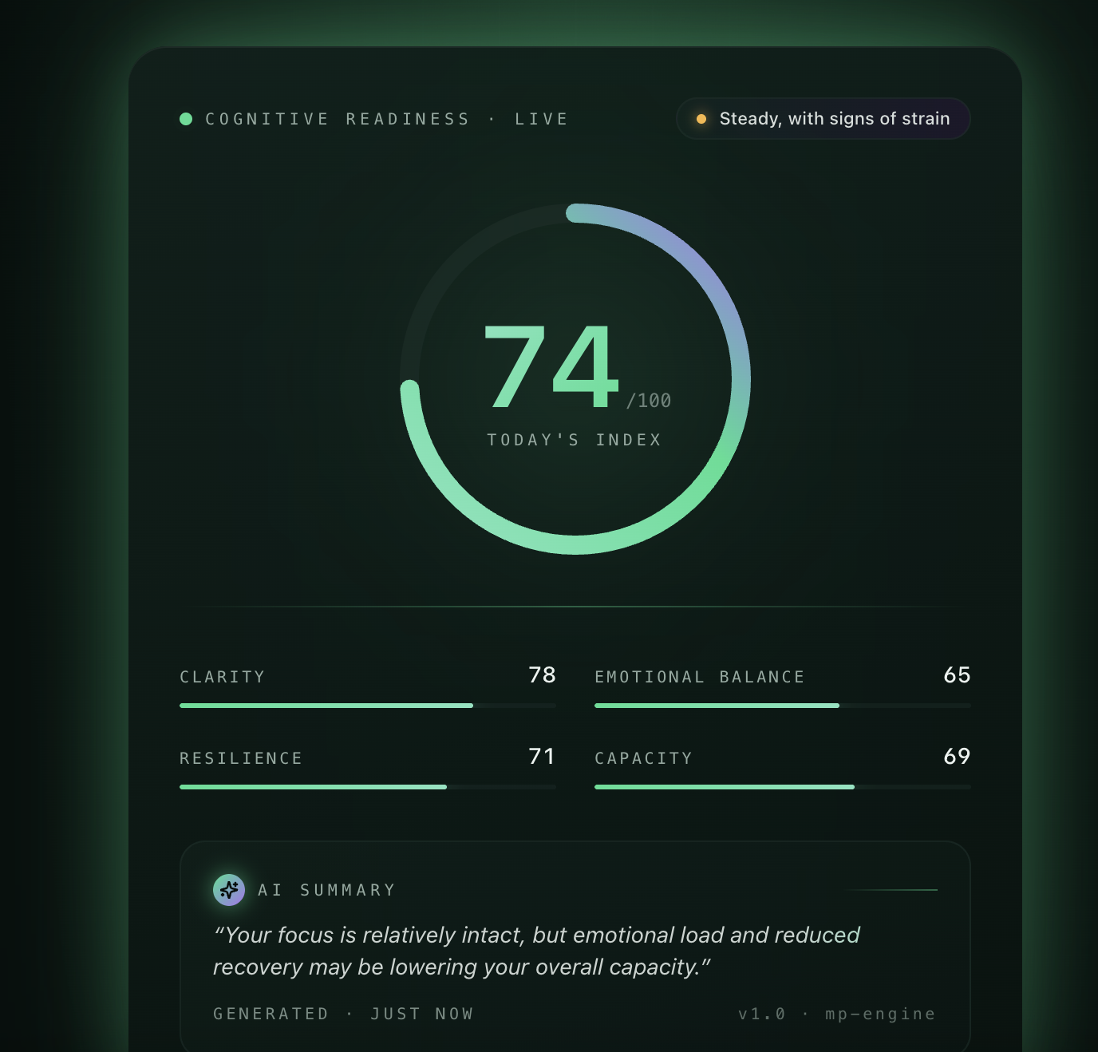

Build an AI-powered mental health report that combines biological, behavioural, and assessment (CORE-OM) signals into a single user-facing score called Cognitive Readiness Score, supported by 4 secondary dimensions:
- Clarity
- Emotional Balance
- Resilience
- Capacity
The report should answer:
- Where am I right now?
- Why am I here?
- What should I be aware of?
- What is the risk?
- What should I do next?

LIFESTYLE TRACKER SCREEN - 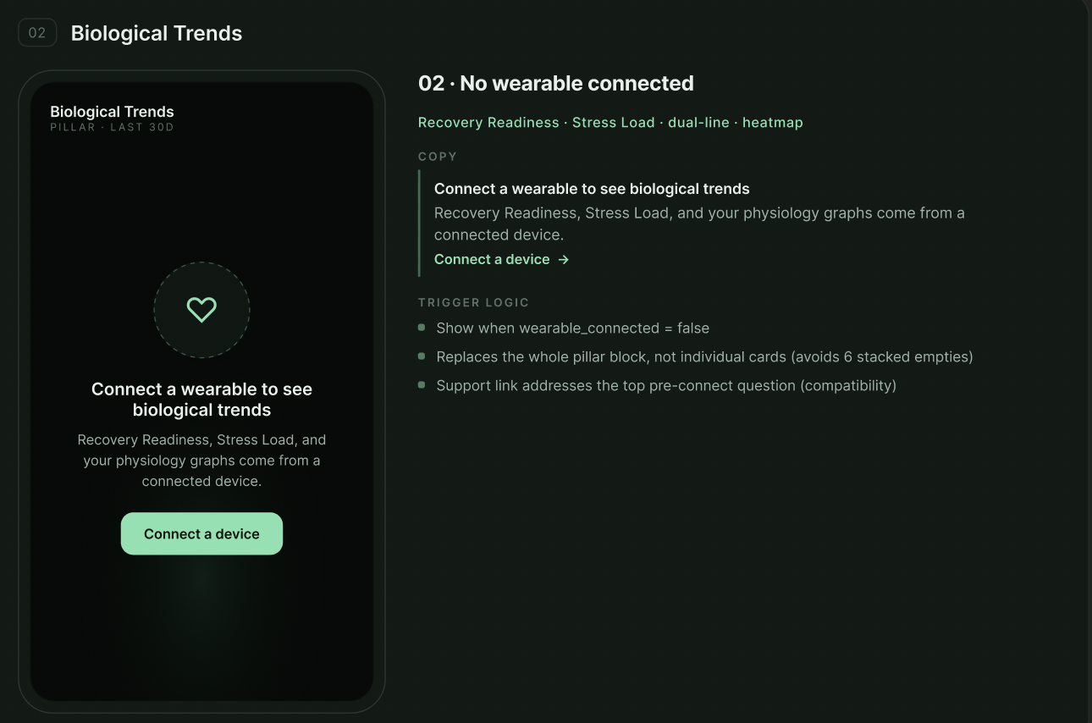

ASSESSMENT SCREEN -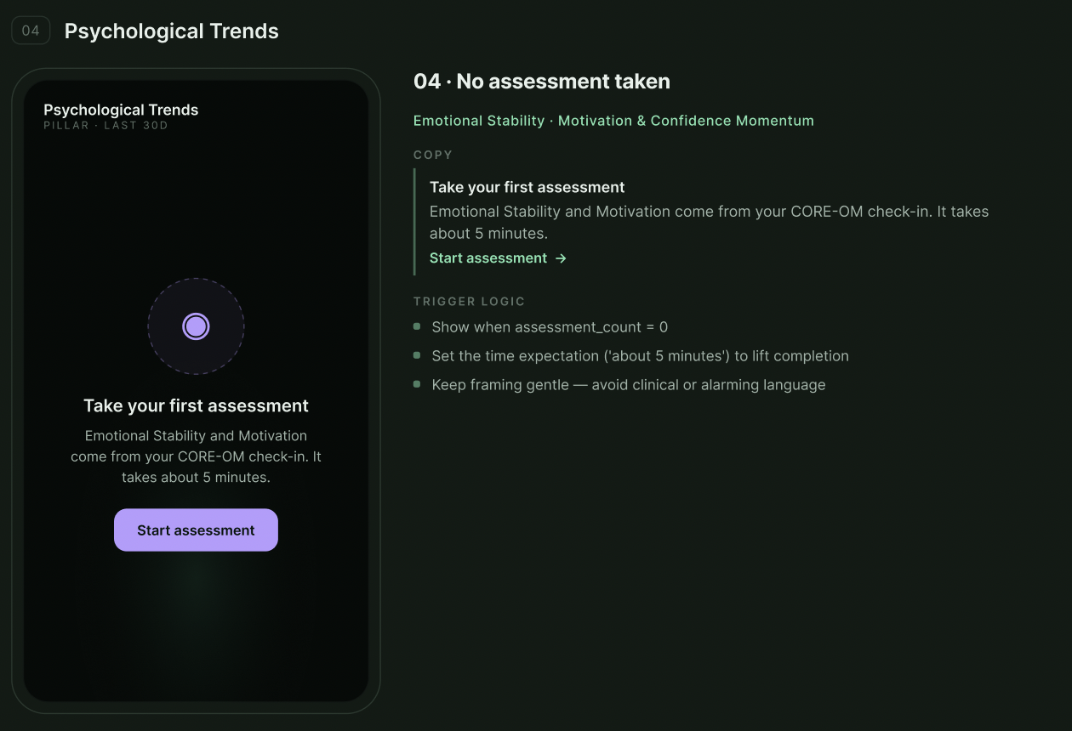
DAILY CHECK IN SCREEN -

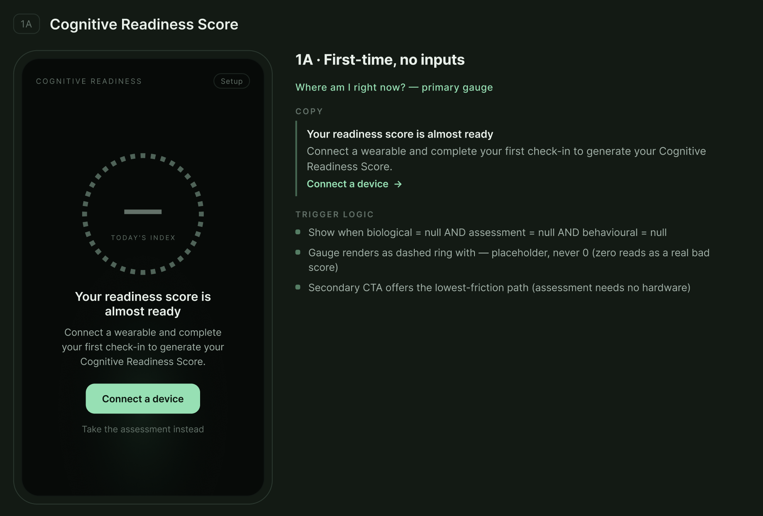
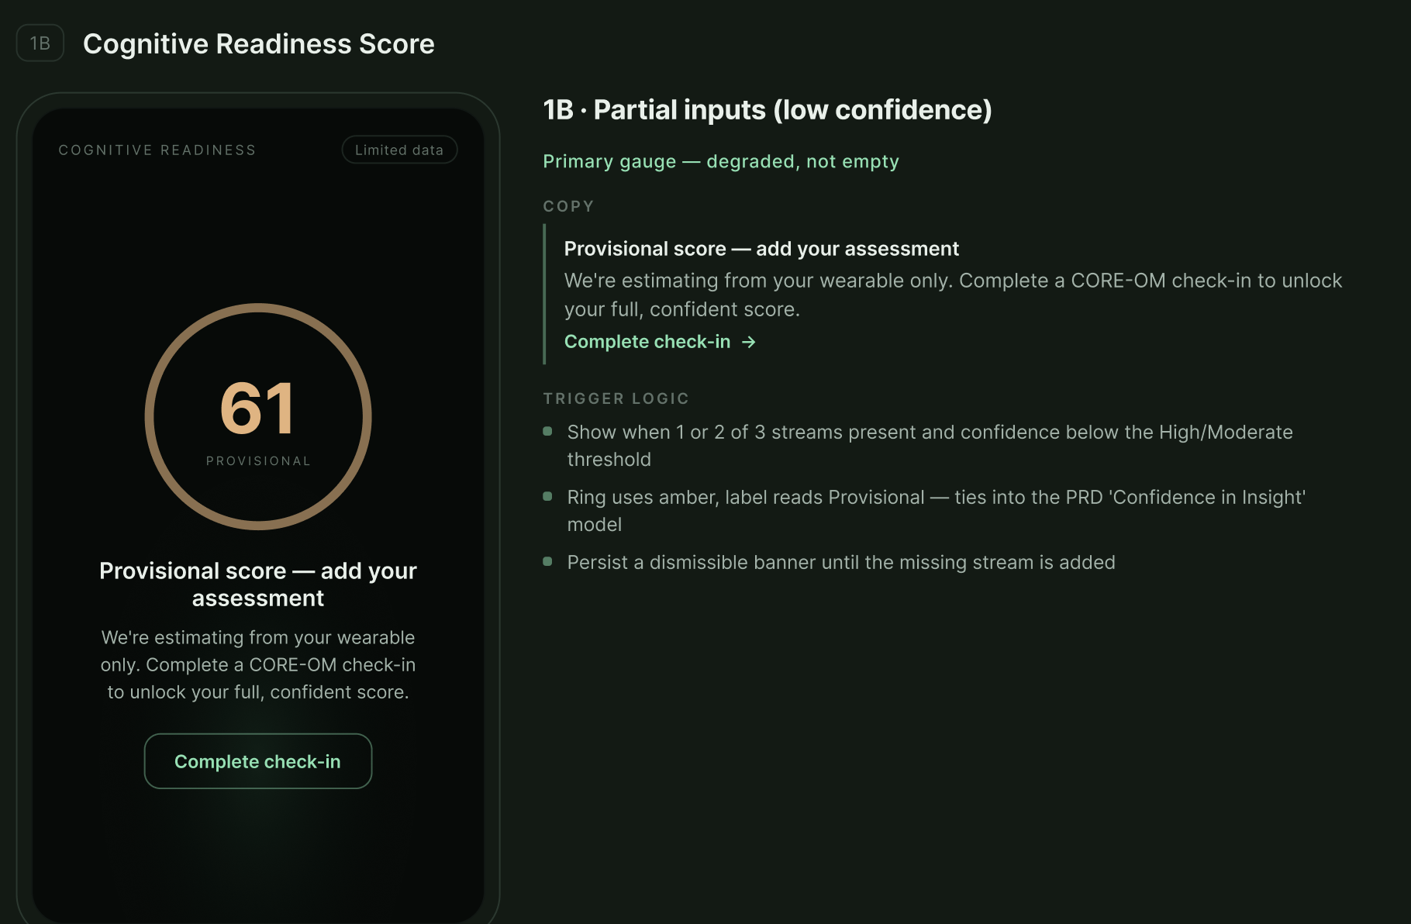
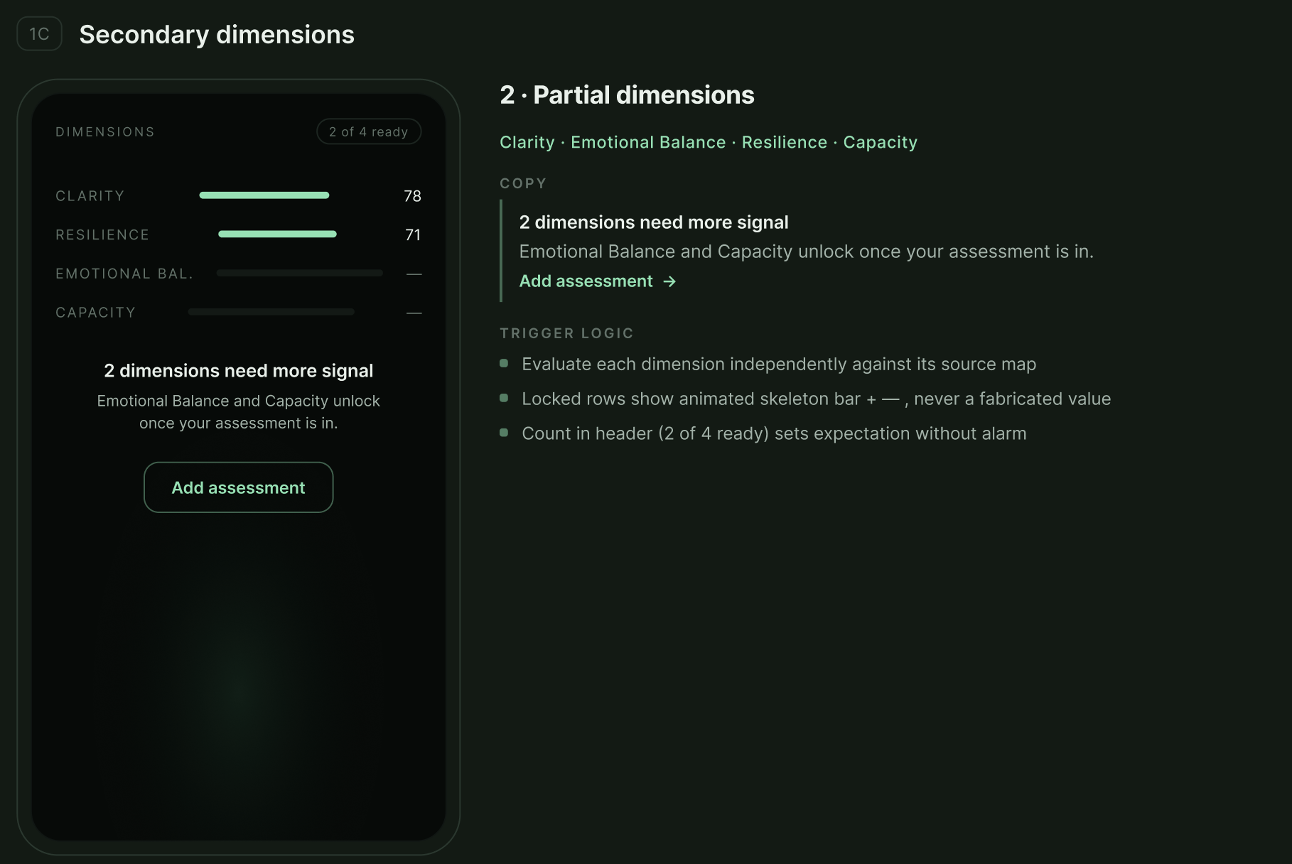

1. Cognitive Readiness Score
Meaning: Overall mental readiness today — how prepared the user is to think, regulate, perform, and sustain daily demands.

Use these sheet parameters | Source in sheet | Why it matters
CORE-OM Overall Score | 360° Mental Well-Being Test | Overall psychological wellbeing and distress indicator.
CORE-OM Life Functioning Difficulties | 360° Mental Well-Being Test | Shows whether the user is able to function in daily/work life.
CORE-OM Problems Score | 360° Mental Well-Being Test | Captures symptom burden impacting readiness.
CORE-OM Wellbeing Score | 360° Mental Well-Being Test | Indicates emotional and mental wellbeing state.
CORE-OM Risk Score | 360° Mental Well-Being Test | Should act as a cap/override if elevated.
Anxiety Score | Backend assessment scoring | Anxiety directly reduces mental readiness and decision-making clarity.
Depression Score | Backend assessment scoring | Low mood and depressive symptoms reduce motivation and capacity.
Trauma Score | Backend assessment scoring | Trauma load may affect regulation, sleep, and resilience.
Sleep | Lifestyle Tracker | Sleep duration, quality, and variability should anchor readiness.
Fatigue | Lifestyle Tracker | Strong daily indicator of burnout, low capacity, or poor recovery.
HRV | Lifestyle Tracker | Nervous-system recovery and resilience marker.
Pulse Rate | Lifestyle Tracker | Physiological arousal/stress signal.
Exercise | Lifestyle Tracker | Movement and physical regulation signal.
Nutrition | Lifestyle Tracker | Impacts energy, mood, and cognition.
Hydration | Lifestyle Tracker | Impacts focus, fatigue, and mood.
Cortisol | Biomarker | Stress-load index; useful for burnout/stress context.
Thyroid / TSH | Biomarker | Can explain fatigue, low mood, anxiety, restlessness.
Blood Sugar | Biomarker | Fluctuations can affect irritability, brain fog, anxiety.
Mood Check-In | Check-In | Emotional state trend and volatility.
Motivation Check-In | Check-In | Drive, engagement, burnout signal.
Confidence Check-In | Check-In | Self-belief and identity-linked performance signal.
Memory Game | Games | Attention, recall, and clarity signal.
Connect Four | Games | Problem-solving, patience, decision-making under pressure.
Journaling tone/themes | Journal | Emotional tone, stress themes, self-talk, recovery signals.

2. Clarity Score
Meaning: Mental sharpness, focus, attention, recall, and cognitive organisation.

Use these sheet parameters | Source in sheet | Why it matters
Memory Game | Games | Direct signal for attention span, recall accuracy, and mental clarity.
Connect Four | Games | Indicates planning depth, patience, and decision-making under pressure.
Sleep | Lifestyle Tracker | Poor sleep directly affects attention, memory, and focus.
Fatigue | Lifestyle Tracker | High fatigue reduces cognitive sharpness.
HRV | Lifestyle Tracker | Low HRV can indicate poor recovery and cognitive strain.
Pulse Rate | Lifestyle Tracker | High pulse trend may show stress/arousal affecting clarity.
Hydration | Lifestyle Tracker | Dehydration can impact fatigue and focus.
Nutrition | Lifestyle Tracker | Poor nutrition consistency can affect energy and cognition.
Hunger | Lifestyle Tracker | Hunger timing/intensity can contextualize irritability and low focus.
Blood Sugar | Biomarker | Fluctuations can explain brain fog, irritability, and anxiety.
Thyroid / TSH | Biomarker | Thyroid imbalance may explain fatigue, restlessness, or low mood.
Vitamin D | Biomarker | Deficiency can contribute to low mood and low energy.
CORE-OM Functioning Score | Assessment | Poor functioning often shows reduced cognitive organisation.
CORE-OM Problems Score | Assessment | Symptom load affects focus and decision-making.
Motivation Check-In | Check-In | Low motivation may indicate cognitive fatigue or disengagement.

3. Emotional Balance Score
Meaning: Emotional steadiness, distress load, mood volatility, and regulation.

Use these sheet parameters | Source in sheet | Why it matters
Mood Check-In | Check-In | Tracks emotional trends and volatility.
Motivation Check-In | Check-In | Decline may indicate burnout, disengagement, or depressive pattern.
Confidence Check-In | Check-In | Low/fluctuating confidence links to self-esteem and impostor themes.
Blank Slate Journal | Journaling | Captures raw emotional tone and dominant themes.
Letter to Self | Journaling | Reveals self-talk, guilt, hope, self-criticism, identity themes.
Gratitude Journal / Letter | Journaling | Positive affect and emotional recovery signal.
Whack A Mole | Games | Can act as emotional regulation/frustration signal.
CORE-OM Wellbeing Score | Assessment | Direct wellbeing indicator.
CORE-OM Problems Score | Assessment | Symptom/distress load.
CORE-OM Risk Score | Assessment | Safety and escalation marker.
Anxiety Score | Backend scoring | Strong emotional arousal/distress marker.
Depression Score | Backend scoring | Low mood, hopelessness, emotional flattening.
Trauma Score | Backend scoring | Emotional reactivity and regulation context.
Sleep | Lifestyle Tracker | Sleep disruption increases emotional reactivity.
Fatigue | Lifestyle Tracker | Fatigue can worsen irritability and distress.
Libido | Lifestyle Tracker | Deviations may indicate stress, depression, hormonal shifts.
Cortisol | Biomarker | Chronic elevation linked to anxiety, burnout, sleep disruption.
Blood Sugar | Biomarker | Fluctuations can worsen anxiety, irritability, mood swings.
Thyroid / TSH | Biomarker | Hypothyroid/hyperthyroid states can mimic depression/anxiety.

4. Resilience Score
Meaning: Recovery capacity, adaptability, coping strength, and ability to bounce back from stress.

Use these sheet parameters | Source in sheet | Why it matters
HRV | Lifestyle Tracker | Core nervous-system recovery and resilience marker.
Sleep | Lifestyle Tracker | Sleep quality and variability anchor recovery.
Exercise | Lifestyle Tracker | Frequency and intensity support stress regulation and resilience.
Fatigue | Lifestyle Tracker | Persistent fatigue may show poor recovery or burnout.
Sun Exposure | Lifestyle Tracker | Supports mood, circadian rhythm, and Vitamin D context.
Nutrition | Lifestyle Tracker | Consistency and quality support energy and recovery.
Hydration | Lifestyle Tracker | Supports energy, mood, and fatigue regulation.
Cortisol | Biomarker | Chronic stress-load marker.
Vitamin D | Biomarker | Deficiency can affect mood and recovery.
Thyroid / TSH | Biomarker | Helps identify biological contributors to fatigue/mood instability.
CORE-OM Delta / Previous Scores | Assessment | Improvement over time is a strong resilience indicator.
CORE-OM Functioning Score | Assessment | Shows ability to sustain daily life despite stressors.
CORE-OM Risk Score | Assessment | High risk should reduce/cap resilience score.
Gratitude Journal / Letter | Journaling | Rising positivity can indicate emotional recovery.
Motivation Check-In | Check-In | Sustained motivation suggests better coping capacity.
App engagement / support-seeking frequency | Platform usage | Healthy engagement can indicate active coping.
Guides/helpful content usage | Tools | Shows whether interventions are being used and found helpful.

5. Capacity Score
Meaning: Available functional bandwidth — ability to handle work, relationships, routine, and daily demands.

Use these sheet parameters | Source in sheet | Why it matters
CORE-OM Life Functioning Difficulties | Assessment | Best direct marker for daily functional bandwidth.
CORE-OM Overall Score | Assessment | Overall distress/wellbeing context.
CORE-OM Problems Score | Assessment | Symptom burden reducing capacity.
CORE-OM Risk Score | Assessment | Should cap capacity if elevated.
Sleep | Lifestyle Tracker | Determines recovered energy.
Fatigue | Lifestyle Tracker | Direct daily capacity signal.
Exercise | Lifestyle Tracker | Indicates energy regulation and physical activation.
Nutrition | Lifestyle Tracker | Impacts sustained energy.
Hydration | Lifestyle Tracker | Affects fatigue, focus, and mood.
Hunger | Lifestyle Tracker | Timing/intensity can explain irritability or energy crashes.
Pulse Rate | Lifestyle Tracker | Physiological stress/arousal marker.
HRV | Lifestyle Tracker | Recovery and stress-readiness signal.
Blood Sugar | Biomarker | Energy instability and brain fog context.
Thyroid / TSH | Biomarker | Explains fatigue, low mood, restlessness.
HbA1c | Biomarker | Metabolic fatigue and mood instability context.
Weight Change | Biomarker | Can indicate chronic stress, anxiety, or depression patterns.
Motivation Check-In | Check-In | Drive and functional engagement signal.
Confidence Check-In | Check-In | Ability to act, decide, and engage.
Session booking / therapy engagement | Session data | Active support-seeking can contextualize capacity needs.

Therapist Inputs for Each Score: https://docs.google.com/spreadsheets/d/1yXdZRUPRWBpzAOD4MToN2tVtHtmu312ofC2c3-bTBIc/edit?usp=sharing

Detailed Weighting by Score

A. Cognitive Readiness Score — 100%

Input Category | Weight | Parameters
Assessment Inputs | 30% | CORE-OM overall, functioning, problems, wellbeing, risk, anxiety score, depression score, trauma score
Lifestyle + Biomarker Inputs | 30% | Sleep, fatigue, HRV, pulse rate, cortisol, blood sugar, thyroid/TSH, hydration, nutrition
Tools / Behavioural Inputs | 15% | Mood check-in, motivation check-in, Memory Game, Connect Four, app engagement
Forms Inputs | 15% | Therapy intent, primary concern, free-text concern, work-stress pattern, routine disruption, check-in completion
Therapist / Session Inputs | 10% | Refer to the sheet: https://docs.google.com/spreadsheets/d/1yXdZRUPRWBpzAOD4MToN2tVtHtmu312ofC2c3-bTBIc/edit?usp=sharing

B. Clarity Score — 100%

Input Category | Weight | Parameters
Tools / Behavioural Inputs | 30% | Memory Game, Connect Four, focus-related app behaviour, completion/drop-off patterns
Lifestyle + Biomarker Inputs | 25% | Sleep, fatigue, hydration, nutrition, HRV, pulse rate, blood sugar, thyroid/TSH, Vitamin D
Assessment Inputs | 20% | CORE-OM functioning, CORE-OM problems, anxiety score, ADHD-related assessment if available
Forms Inputs | 15% | Overthinking themes, decision fatigue, focus concerns, self-reported brain fog, work-pressure patterns
Therapist / Session Inputs | 10% | Refer to the sheet: https://docs.google.com/spreadsheets/d/1yXdZRUPRWBpzAOD4MToN2tVtHtmu312ofC2c3-bTBIc/edit?usp=sharing

C. Emotional Balance Score — 100%

Input Category | Weight | Parameters
Assessment Inputs | 35% | CORE-OM wellbeing, problems, risk, anxiety score, depression score, trauma score
Forms Inputs | 20% | Emotional triggers, relationship patterns, self-talk themes, concern severity, free-text emotional tone, crisis/risk markers
Tools / Behavioural Inputs | 20% | Mood check-in, confidence check-in, journaling sentiment, gratitude journal, Whack A Mole, check-in drop-off
Lifestyle + Biomarker Inputs | 20% | Sleep, fatigue, cortisol, blood sugar, thyroid/TSH, libido, pulse rate
Therapist / Session Inputs | 5% | Refer to the sheet: https://docs.google.com/spreadsheets/d/1yXdZRUPRWBpzAOD4MToN2tVtHtmu312ofC2c3-bTBIc/edit?usp=sharing

D. Resilience Score — 100%

Input Category | Weight | Parameters
Lifestyle + Biomarker Inputs | 30% | HRV, sleep, exercise, fatigue, nutrition, hydration, sun exposure, Vitamin D, cortisol
Assessment Inputs | 25% | CORE-OM previous scores, CORE-OM delta, CORE-OM functioning, risk score
Forms Inputs | 20% | Pattern improvement, coping behaviour, motivation trend, trigger reduction, therapy intent vs progress
Tools / Behavioural Inputs | 15% | Gratitude journal, app engagement, guide usage, support-seeking frequency, check-in consistency
Therapist / Session Inputs | 10% | Refer to the sheet: https://docs.google.com/spreadsheets/d/1yXdZRUPRWBpzAOD4MToN2tVtHtmu312ofC2c3-bTBIc/edit?usp=sharing

E. Capacity Score — 100%

Input Category | Weight | Parameters
Assessment Inputs | 30% | CORE-OM functioning, overall score, problems score, risk score
Lifestyle + Biomarker Inputs | 30% | Sleep, fatigue, HRV, pulse rate, exercise, nutrition, hydration, blood sugar, HbA1c, thyroid/TSH, weight change
Forms Inputs | 20% | Work functioning concerns, burnout patterns, fatigue-related responses, missed check-ins, daily routine difficulty, self-reported overwhelm
Therapist / Session Inputs | 10% | Session attendance, missed/cancelled sessions, time since last session, therapist availability, affordability/fee continuity, mode/language match
Tools / Behavioural Inputs | 10% | Refer to the sheet: https://docs.google.com/spreadsheets/d/1yXdZRUPRWBpzAOD4MToN2tVtHtmu312ofC2c3-bTBIc/edit?usp=sharing

